

NATIONAL UNIVERSITY OF COMPUTER AND EMERGING SCIENCE

Mini Instagram

GROUP MEMBERS

Name Roll No

Talha Abdullah Bangyal | 22F- 3194
Mian Muhammad Ammar | 22F- 3102

Table of Contents
Codes 3
menu.h 3
menu.cpp 3
graph.h 4
graph.cpp 4
crediential.h 6
crediential.cpp 7
data.h 7
data.cpp 9
main.cpp 11
Screenshot 14
Signup 14
For Talha 14
For Abdullah 15
Login 15
For Talha 15
For Abdullah 16
Logout 16
For Talha 16
For Abdullah 17
Send Friend Request 17
For Talha 17
For Abdullah 18
View Notifications 18
For Talha 18
For Abdullah 19
Post Content 19
For Talha 19
For Abdullah 20
View Posts 20
For Talha 20
For Abdullah 21
Send Message 21
For Talha 21
For Abdullah 22
View Messages 22
For Talha 22
For Abdullah 23
View Friends 23
For Talha 23
For Abdullah 24
View Friend Request 24
For Talha 24
For Abdullah 25
Accept Friend Request 25
For Talha 25
For Abdullah 26
Reject Friend Request 26
For Talha 26
For Abdullah 27
Exit 27

Codes

menu.h
#ifndef MENU_H
#define MENU_H
#pragma once
#include <iostream>
#include <string>
#include <ctime>
using namespace std;

void displayMenu();
string getCurrentTimestamp();
#endif

menu.cpp
#include"menu.h"

// Main Menu
void displayMenu() {
cout << "--- Mini Instagram ---" << endl;
cout << "1. Signup" << endl;
cout << "2. Login" << endl;
cout << "3. Logout" << endl;
cout << "4. Send Friend Request" << endl;
cout << "5. View Notifications" << endl;
cout << "6. Post Content" << endl;
cout << "7. View Posts" << endl;
cout << "8. Send Message" << endl;
cout << "9. View Messages" << endl;
cout << "10. View Friends" << endl;
cout << "11. View Friend Request" << endl;
cout << "12. Accept Friend Request" << endl;
cout << "13. Reject Friend Request" << endl;
cout << "0. Exit" << endl;
cout << "Enter your choice: ";
}

// Helper Function to Get Current Timestamp
string getCurrentTimestamp() {
time_t now = time(0); // Get current time
char buffer[26]; // Buffer to hold the formatted time
ctime_s(buffer, sizeof(buffer), &now); // Safe version of ctime
return string(buffer); // Return as a string
}

graph.h
#ifndef GRAPH_H
#define GRAPH_H
#pragma once
#include "menu.h"
#include "data.h"

class UserGraph {
UserFriend* head;
UserFriend* findUser(string username) {
UserFriend* temp = head;
while (temp && temp->username != username) {
temp = temp->next;
}
return temp;
}
public:
UserGraph();
void addUser(string username);
void addFriendRequest(string sender, string receiver);
void displayFriendRequests(string username);
void acceptFriendRequest(string username, string sender);
void rejectFriendRequest(string username, string sender);
void displayNotifications(string username);
void displayFriends(string username);
void postContent(string username, string content);
void viewPosts(string username);
void sendMessage(string sender, string receiver, string content);
void viewMessages(string username);
};
#endif

graph.cpp
#include"graph.h"

UserGraph::UserGraph() {
head = nullptr;
}

void UserGraph::addUser(string username) {
if (!findUser(username)) {
UserFriend* newUser = new UserFriend(username);
newUser->next = head;
head = newUser;
}
}

// Function to add a friend request
void UserGraph::addFriendRequest(string sender, string receiver) {
UserFriend* user = findUser(receiver);
if (user) {
user->friendRequests.enqueue(sender + " sent you a friend request.");
}
}

// Function to display incoming friend requests for a user
void UserGraph::displayFriendRequests(string username) {
UserFriend* user = findUser(username);
if (user) {
cout << "Friend Requests for " << username << ":" << endl;
user->friendRequests.display();
cout << "Do you want to accept or reject any request? (Enter 'accept' or 'reject')" << endl;
}
}

// Function to accept a friend request
void UserGraph::acceptFriendRequest(string username, string sender) {
UserFriend* user = findUser(username);
if (user) {
// Add the sender to the user's friend list
FriendNode* newFriend = new FriendNode(sender);
newFriend->next = user->friendsHead;
user->friendsHead = newFriend;

// Remove the notification
string notificationMessage = sender + " sent you a friend request.";
if (user->friendRequests.removeMessage(notificationMessage)) {
cout << "Friend request accepted!" << endl;
}
else {
cout << "Friend request not found." << endl;
}
}
}

// Function to reject a friend request
void UserGraph::rejectFriendRequest(string username, string sender) {
UserFriend* user = findUser(username);
if (user) {
// Remove the notification
string notificationMessage = sender + " sent you a friend request.";
if (user->friendRequests.removeMessage(notificationMessage)) {
cout << "Friend request rejected!" << endl;
}
else {
cout << "Friend request not found." << endl;
}
}
}

void UserGraph::displayNotifications(string username) {
UserFriend* user = findUser(username);
if (user) {
user->notifications.display();
}
}

void UserGraph::displayFriends(string username) {
UserFriend* user = findUser(username);
if (user) {
FriendNode* temp = user->friendsHead;
cout << "Friends of " << username << ": ";
while (temp) {
cout << temp->username << " ";
temp = temp->next;
}
cout << endl;
}
}

void UserGraph::postContent(string username, string content) {
UserFriend* user = findUser(username);
if (user) {
user->posts.push(content);
user->notifications.enqueue("New post added: " + content);
}
}

void UserGraph::viewPosts(string username) {
UserFriend* user = findUser(username);
if (user) {
user->posts.display();
}
}

void UserGraph::sendMessage(string sender, string receiver, string content) {
UserFriend* user = findUser(receiver);
if (user) {
user->messages.push(sender, content);
user->notifications.enqueue(sender + " sent you a message: " + content);
}
}

void UserGraph::viewMessages(string username) {
UserFriend* user = findUser(username);
if (user) {
user->messages.display();
}
}

crediential.h
#ifndef CREDIENTIAL_H
#define CREDIENTIAL_H
#pragma once
#include"menu.h"
#include"data.h"

class CredentialManager {
CredentialNode* head;

public:
CredentialManager();
void addUser(string username, string password);
bool authenticate(string username, string password);
bool findUser(string username);
};
#endif

crediential.cpp
#include"crediential.h"

CredentialManager::CredentialManager() {
head = nullptr;

}

void CredentialManager::addUser(string username, string password) {
if (!findUser(username)) {
CredentialNode* newNode = new CredentialNode(username, password);
newNode->next = head;
head = newNode;
}
}

bool CredentialManager::authenticate(string username, string password) {
CredentialNode* temp = head;
while (temp) {
if (temp->username == username && temp->password == password)
return true;
temp = temp->next;
}
return false;
}

bool CredentialManager::findUser(string username) {
CredentialNode* temp = head;
while (temp) {
if (temp->username == username)
return true;
temp = temp->next;
}
return false;
}

data.h
#ifndef DATA_H
#define DATA_H
#pragma once
#include"data.h"
#include"menu.h"

// Linked List for User Credentials
struct CredentialNode {
string username;
string password;
CredentialNode* next;
CredentialNode(string uname, string pwd);
};

// Linked List Node for Posts
struct Post {
string timestamp;
string content;
Post* next;
Post(string content);
};

// Stack for Posts
struct PostStack {
Post* top;
PostStack();
void push(string content);
void display();
};

// Queue for Friend Requests or Notifications
struct QueueNode {
string message;
QueueNode* next;
QueueNode(string msg);
};

struct Queue {
QueueNode* front;
QueueNode* rear;
Queue();
void enqueue(string msg);
string dequeue();
bool isEmpty();
void display();
bool removeMessage(const string& msg);
};

// Stack for Messages
struct MessageNode {
string sender;
string content;
MessageNode* next;
MessageNode(string sndr, string msg);
};

struct MessageStack {
MessageNode* top;
MessageStack();
void push(string sender, string content);
void display();
};

// Graph for User Relationships
struct FriendNode {
string username;
FriendNode* next;
FriendNode(string uname);
};

struct UserFriend {
string username;
FriendNode* friendsHead;
UserFriend* next;
Queue friendRequests;
Queue notifications;
PostStack posts;
MessageStack messages;

UserFriend(string uname);
};
#endif

data.cpp
#include"menu.h"
#include"data.h"

// Linked List for User Credentials
CredentialNode::CredentialNode(string uname, string pwd) {
username = uname;
password = pwd;
next = nullptr;
}

// Linked List Node for Posts
Post::Post(string content) {
timestamp = getCurrentTimestamp();
this->content = content;
next = nullptr;
}

// Stack for Posts
PostStack::PostStack() {
top = nullptr;
}
void PostStack::push(string content) {
Post* newPost = new Post(content);
newPost->next = top;
top = newPost;
}

void PostStack::display() {
Post* temp = top;
if (!temp) {
cout << "No posts available." << endl;
return;
}
while (temp) {
cout << temp->timestamp << ": " << temp->content << endl;
temp = temp->next;
}
}

// Queue for Friend Requests or Notifications
QueueNode::QueueNode(string msg) {
message = msg;
next = nullptr;
}

Queue::Queue() {
front = nullptr;
rear = nullptr;
}

void Queue::enqueue(string msg) {
QueueNode* newNode = new QueueNode(msg);
if (rear) {
rear->next = newNode;
}
else {
front = newNode;
}
rear = newNode;
}

string Queue::dequeue() {
if (!front) return "Queue is empty.";
QueueNode* temp = front;
string msg = front->message;
front = front->next;
if (!front) rear = nullptr;
delete temp;
return msg;
}

bool Queue::isEmpty() {
return front == nullptr;
}

void Queue::display() {
QueueNode* temp = front;
if (!temp) {
cout << "Queue is empty." << endl;
return;
}
while (temp) {
cout << temp->message << endl;
temp = temp->next;
}
}
bool Queue::removeMessage(const string& msg) {
if (!front) return false; // Queue is empty

// If the message is at the front
if (front->message == msg) {
QueueNode* temp = front;
front = front->next;
if (!front) rear = nullptr;
delete temp;
return true;
}

// Search for the message in the rest of the queue
QueueNode* temp = front;
while (temp->next) {
if (temp->next->message == msg) {
QueueNode* toDelete = temp->next;
temp->next = temp->next->next;
if (temp->next == nullptr) rear = temp; // Update rear if necessary
delete toDelete;
return true;
}
temp = temp->next;
}

return false; // Message not found
}

// Stack for Messages
MessageNode::MessageNode(string sndr, string msg) {
sender = sndr;
content = msg;
next = nullptr;
}

MessageStack::MessageStack() {
top = nullptr;
}

void MessageStack::push(string sender, string content) {
MessageNode* newNode = new MessageNode(sender, content);
newNode->next = top;
top = newNode;
}

void MessageStack::display() {
MessageNode* temp = top;
if (!temp) {
cout << "No messages available." << endl;
return;
}
while (temp) {
cout << temp->sender << ": " << temp->content << endl;
temp = temp->next;
}
}

// Graph for User Relationships
FriendNode::FriendNode(string uname) {
username = uname;
next = nullptr;
}

UserFriend::UserFriend(string uname) {
username = uname;
friendsHead = nullptr;
next = nullptr;
}

main.cpp
#include"menu.h"
#include"graph.h"
#include"crediential.h"
#include"data.h"

int main() {
UserGraph userGraph;
CredentialManager credentials;
string currentLoggedInUser;

while (true) {
displayMenu();
int choice;
cin >> choice;
if (choice == 0) break;

string username, password, friendName, content, sender, receiver;
switch (choice) {
case 1: // Signup
cout << "Enter username: ";
cin >> username;
cout << "Enter password: ";
cin >> password;
if (!credentials.findUser(username)) {
credentials.addUser(username, password);
userGraph.addUser(username);
cout << "Signup successful!" << endl;
}
else {
cout << "Username already exists." << endl;
}
break;

case 2: // Login
if (!currentLoggedInUser.empty()) {
cout << "You are already logged in as " << currentLoggedInUser << ". Logout first." << endl;
break;
}
cout << "Enter username: ";
cin >> username;
cout << "Enter password: ";
cin >> password;
if (credentials.authenticate(username, password)) {
currentLoggedInUser = username;
cout << "Login successful! Welcome, " << username << "." << endl;
}
else {
cout << "Invalid username or password." << endl;
}
break;

case 3: // Logout
if (!currentLoggedInUser.empty()) {
cout << "Goodbye, " << currentLoggedInUser << "." << endl;
currentLoggedInUser.clear();
}
else {
cout << "No user is currently logged in." << endl;
}
break;

case 4: // Send Friend Request
if (currentLoggedInUser.empty()) {
cout << "Please login first." << endl;
break;
}
cout << "Enter friend's username: ";
cin >> friendName;
userGraph.addFriendRequest(currentLoggedInUser, friendName);
cout << "Friend request sent!" << endl;
break;

case 5: // View Notifications
if (currentLoggedInUser.empty()) {
cout << "Please login first." << endl;
break;
}
userGraph.displayNotifications(currentLoggedInUser);
break;

case 6: // Post Content
if (currentLoggedInUser.empty()) {
cout << "Please login first." << endl;
break;
}
cout << "Enter post content: ";
cin.ignore();
getline(cin, content);
userGraph.postContent(currentLoggedInUser, content);
cout << "Post added!" << endl;
break;

case 7: // View Posts
if (currentLoggedInUser.empty()) {
cout << "Please login first." << endl;
break;
}
userGraph.viewPosts(currentLoggedInUser);
break;

case 8: // Send Message
if (currentLoggedInUser.empty()) {
cout << "Please login first." << endl;
break;
}
cout << "Enter receiver's username: ";
cin >> receiver;
cout << "Enter message content: ";
cin.ignore();
getline(cin, content);
userGraph.sendMessage(currentLoggedInUser, receiver, content);
cout << "Message sent!" << endl;
break;

case 9: // View Messages
if (currentLoggedInUser.empty()) {
cout << "Please login first." << endl;
break;
}
userGraph.viewMessages(currentLoggedInUser);
break;

case 10: // View Friends
if (currentLoggedInUser.empty()) {
cout << "Please login first." << endl;
break;
}
userGraph.displayFriends(currentLoggedInUser);
break;
case 11: // View Friend Requests
if (currentLoggedInUser.empty()) {
cout << "Please login first." << endl;
break;
}
userGraph.displayFriendRequests(currentLoggedInUser);
break;

case 12: // Accept Friend Request
if (currentLoggedInUser.empty()) {
cout << "Please login first." << endl;
break;
}
cout << "Enter sender's username to accept the friend request: ";
cin >> sender;
userGraph.acceptFriendRequest(currentLoggedInUser, sender);
break;

case 13: // Reject Friend Request
if (currentLoggedInUser.empty()) {
cout << "Please login first." << endl;
break;
}
cout << "Enter sender's username to reject the friend request: ";
cin >> sender;
userGraph.rejectFriendRequest(currentLoggedInUser, sender);
break;

default:
cout << "Invalid choice." << endl;
}
}

return 0;
}

Screenshot

Signup

For Talha
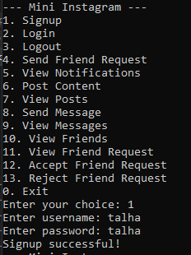

For Abdullah
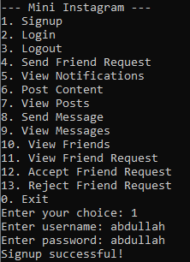

Login

For Talha
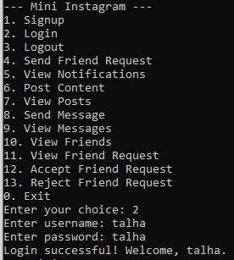

For Abdullah
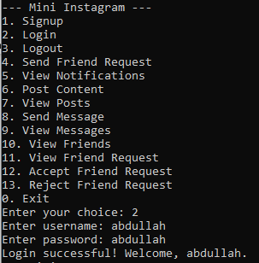

Logout

For Talha
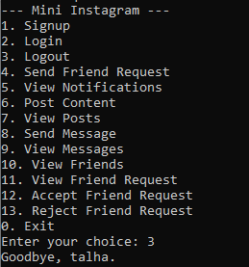

For Abdullah
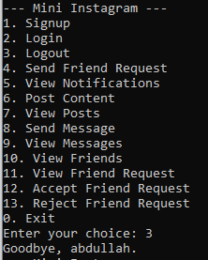

Send Friend Request

For Talha
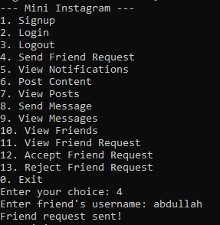

For Abdullah
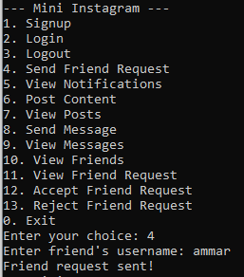

View Notifications

For Talha
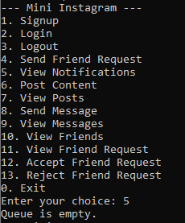

For Abdullah
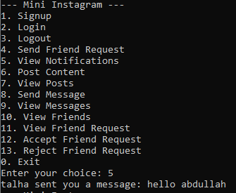

Post Content

For Talha
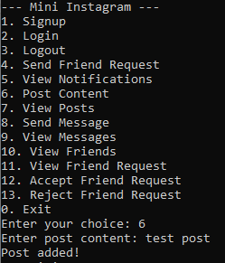

For Abdullah
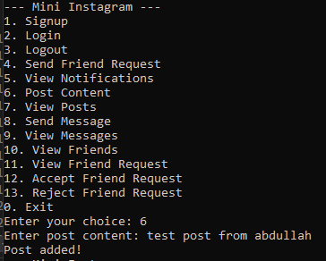

View Posts

For Talha
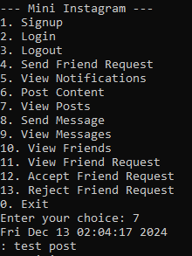

For Abdullah
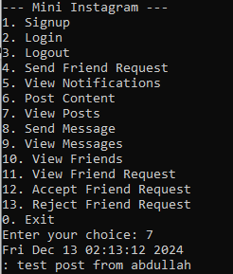

Send Message

For Talha
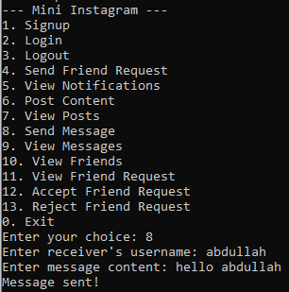

For Abdullah
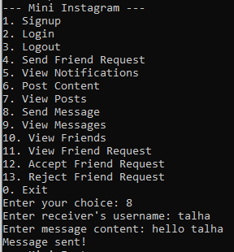

View Messages

For Talha
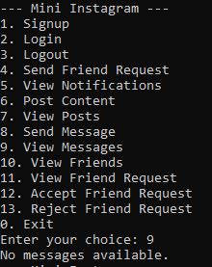

For Abdullah
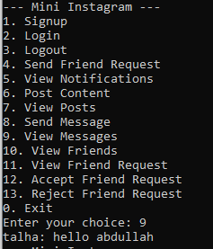

View Friends

For Talha
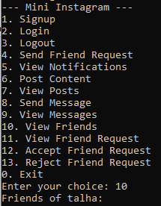
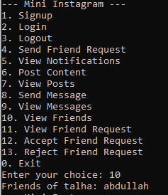

For Abdullah
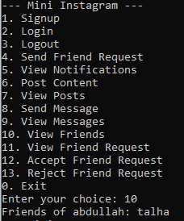

View Friend Request

For Talha
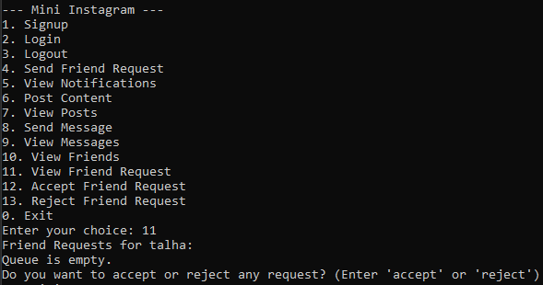

For Abdullah
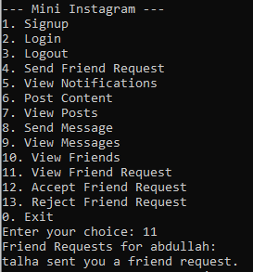

Accept Friend Request

For Talha
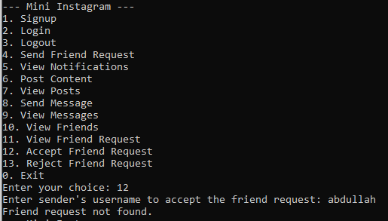

For Abdullah
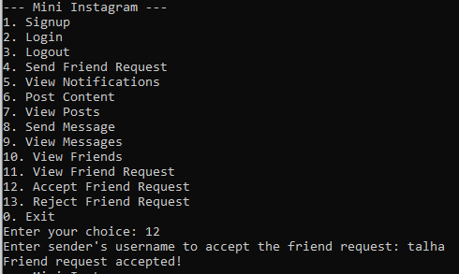

Reject Friend Request

For Talha
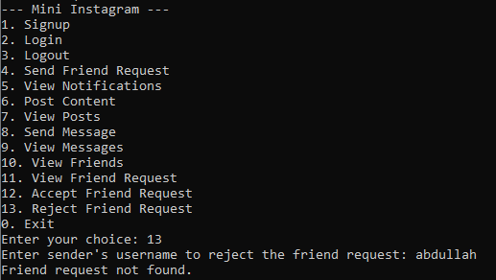

For Abdullah
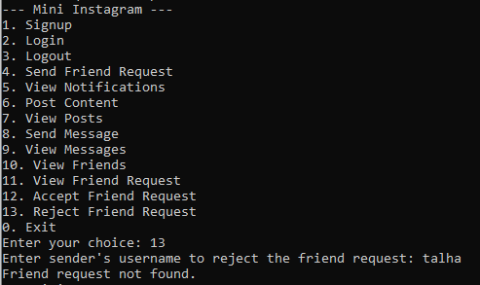

Exit
